Open-loop signature. New design.

# What is open-loop signature?

This is a sweep of valve position from a specified start position to a specified end position with a specified speed, while collecting “signature data”, currently, position and main pressure.

Unlike closed-loop signature which roughly amounts to ramping the position setpoint from start to end, open-loop signature sweeps the output (aka control output) from start to end with a certain rate so as to cause a desired position sweep.

Start and end positions can be (slightly) outside of operating range.

So, an open-loop signature algorithm must

1. Establish estimates start and end control output and control output rate. It must be acknowledged that the estimates are rough and using them requires additional guards
2. Put the valve at the start position
3. Ramp control output toward the end position with the determined control output rate. Note that data sampling while the valve is not moving eats away from the total number of points collected.
4. Check the end conditions and end the sweep when conditions are met.

# Deficiencies of the current algorithm

While the algorithm works pretty well on a single-acting (SA) valve, it performs rather poorly on a double-acting (DA) valve. Surprisingly, this is so even on a DA valve with a spring. See Appendix A.

Unfortunately, multiple, numerous, and long efforts to patch it up didn’t succeed. This gave rise to a complete rewrite with a new algorithm described below.

A deep dive into the old algorithm is out of scope of this document, but the summary is this:

1. On occasion, the end conditions could never be met, or even the valve would not move toward end position at all
2. Stabilization of the valve at a stop could take a very long time relative to the time of full sweep. That can fill the data buffer with useless data, leaving little or no room to data within the sweep.

It appears that the root cause of this is overreliance on relationship between control output and actuator 1 pressure (P1). In a DA valve, it is quite complex and dynamic, so it is best not to rely on it at all. Here is an example of P1 and P2 response to a control output step:

This is going 100%->10%:

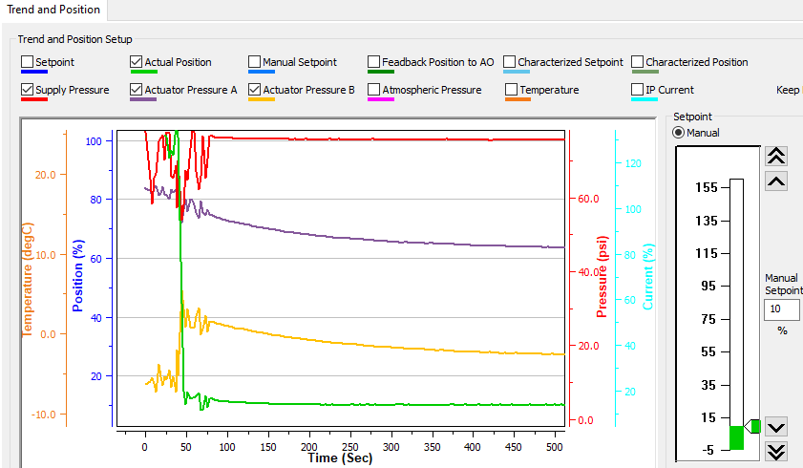

And this, 10%->90%

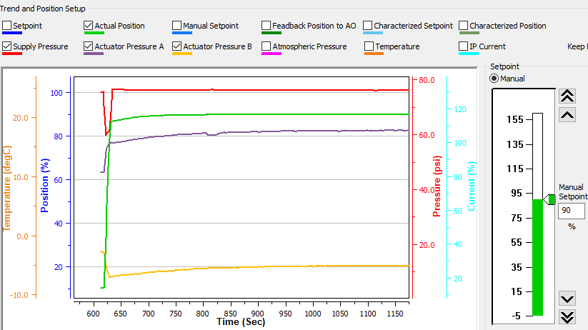

Oh, and there is a formula error in computing the control output changer per step.

# The new algorithm

The new algorithm makes no use of pressures, except, optionally, for a trivial case to end the sweep when P1 hits supply (in the energized direction) or 0 (in the deenergized direction), of course with allowances.

## Determine control output step and range

Like in the original algorithm, we begin with stabilizing the valve in closed loop at the start position but not closer to the stop than 10%. However, the criterion of stability is not stable position and pressure, but instead, stable position at the setpoint.

Then, in closed loop, we ramp the setpoint with the specified speed toward end point, while sampling position and control output, in control task context, until position moves at least 3*6%.

Then we parse the diagnostic buffer from the end backwards to determine the last position <= start + 3*6% and record this position (pos1) and control output (control output1). Then we continue to walk the buffer backwards to find the last position <= start + 2*6% record this position (pos0) and control output (control output0)

Now we make an assumption that the valve moved more or less steadily in the desired direction, and make a rough estimate of control output rate per position change as (control output1 – control output0)/(pos1 – pos0). We then linearly extrapolate this to control output difference between end and start positions, and further stretch the result by 2%, just for safety.

NOTE: As a workaround for position noise, we use smoothed position (exponential forgetting of instant position) as a means of averaging. Of course, smoothed position lags the actual position, but since we are interested in position *difference* on a steady ramp course, it works as just noise suppression.

Also, knowing the speed we ramped with, we compute control output change per step from (control output1 – control output0), the step being currently 60 ms – the cycle task period.

## Prepare for and start the control output sweep

We want the valve to be in a good position and direction in order to begin open-loop sweep. To do so, in closed loop, we stabilize the valve 3% away from start position, and then ramp the setpoint at the specified start position. (At this point, it doesn’t matter if any setpoint is out of range, we ramp the setpoint to get the control output going.)

Now we switch to open-loop mode and enable a very special data sampling: not only it samples position and (main) pressure but also increments (and outputs) control output by the computed increment, starting with the value captured at the time of switching to open loop.

From now on, the control output sweep happens automatically by data sampling engine, and but the only problem is when to stop it.

## Control output sweep guard

During control output sweep, we check every 60 ms whether the valve actually moved in the expected direction for the last 480 ms. If not, we nudge the control output base by 10 times control output sweep step.

This serves two purposes.

First is the recognition that we underestimated the control output step, and if during the sweep the valve stalls, we are happy to nudge it a little, or the test may run really long time.

Second, we may have overestimated the control output difference we intend to exercise, especially if the end and/or start positions are outside the range. So, the guard serves as finish accelerator.

## Adaptive control output step

We must recognize that initial control output step estimate (see Determine control output step and range) is very rough and, more importantly, may not be good at all for the whole position range under test. Therefore, we should adapt the control output step to compensate for position change deviation from nominal.

If the valve is not stalled (see Control output sweep guard), we adapt the control output step by comparing expected position speed with actual average position speed over the last 480 ms, compute the corresponding control output step and add it to the exponential forgetting filter of control output step to produce new control output step.

Because of measurement noise and numeric rounding errors, the filter gain is very small, e.g., 1/4096, determined experimentally. Still, it produces meaningful results, and typically shortens the test time significantly, while occasionally preventing “falling off the cliff”.

## Detect the end of sweep

The control output sweep is considered finished if

1. End position is reached, or
2. (Optional, currently removed) P1 is at limit, or
3. (Removed) Control output reached its intended limit, and 30 s more is expired.
4. Valve has not moved in the desired direction in 480 ms for 40 times, after being within 10% of the intended stop.

Note: While waiting for the end of sweep, control output sweep guard is invoked.

## Failure modes

Other than internal failures (betraying firmware bugs), the process may fail if

* the valve moves in the direction opposite to the intended (think losing air)
* if we couldn’t find the good reference positions in the buffer

Other than that, the signature will be guaranteed complete but

1. The actual position change speed may be very different from the specified speed, especially on a DA valve. A partial countermeasure is adaptive control output step.
2. Start position may not be exactly reached. Example: 30 70 2 – Failed to reach start position. The cause is closed loop stability detection error.
3. End position may not be exactly reached. Examples: -2 102 2 – Failed to reach end position (eliminated with removal of end condition 3), or just slightly 102 -2 2, 30 70 2.

A workaround for cases 2 and 3 is simply to extend the test range.

# Appendix A. Examples of open-loop signature failures with SVI FF R2

Shown below are graphical test results for different valves. They are a screenshot of the test run log and if completed, a screenshot of graphical test results.

The elapsed run time always includes saving signature to the device and uploading it to the DTM.

The heading x y z means from x% to y% with a nominal speed z %/s

## Springless DA 51 series

### 102.00%, -2.00% 2

Test didn’t complete and was manually canceled

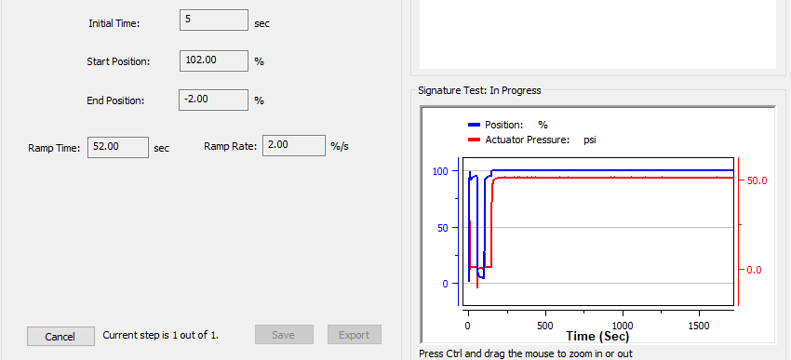

### 95% 5% 2

Not completed. Manually canceled.

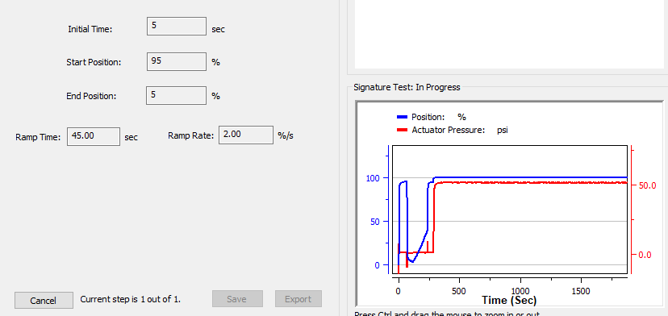

### -4% 104% 2

Signature lost points to incorrect estimate of control output rate.

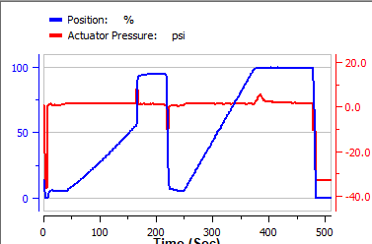

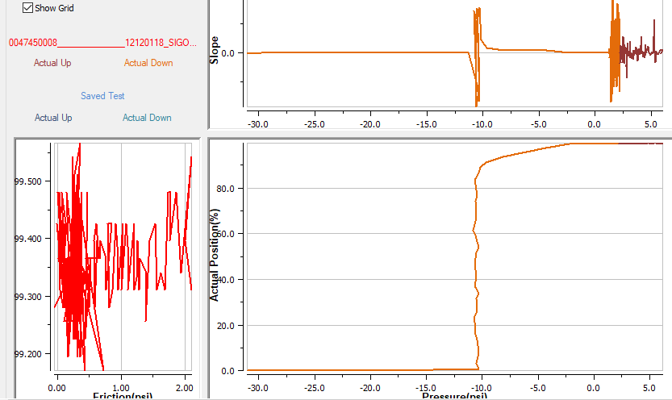

### 20% 80% 2

Failed to capture signature points

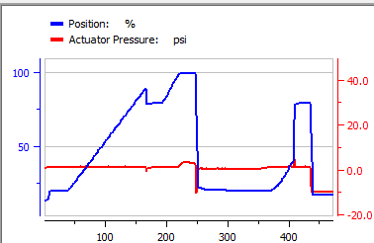

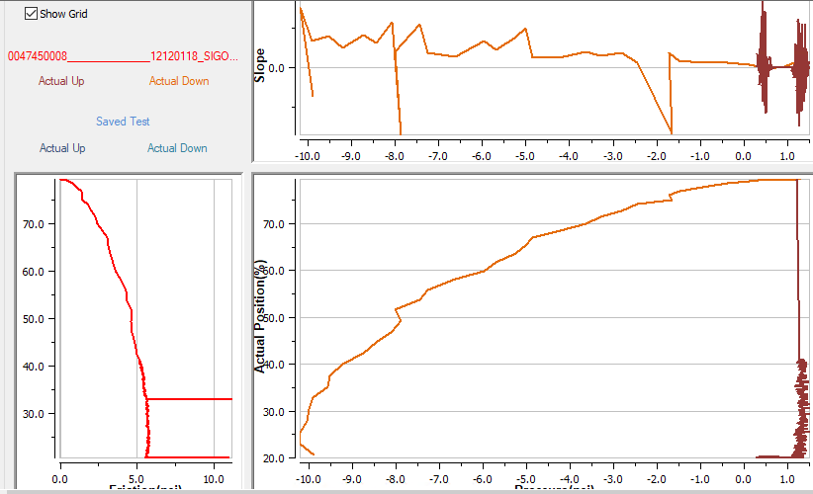

## Morin B-420U-S060 valve DA with a spring

### 95% End 5% 2

Not exactly a failure but unrealistic results

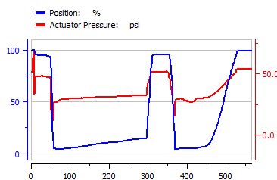

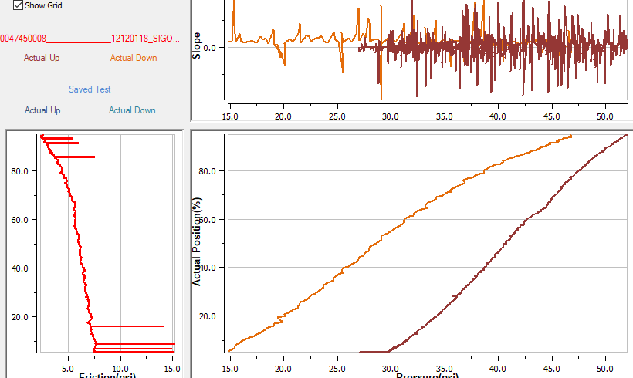

### 104% -4% 2

Failed to move valve

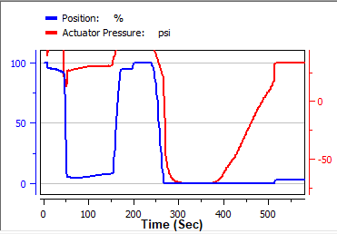

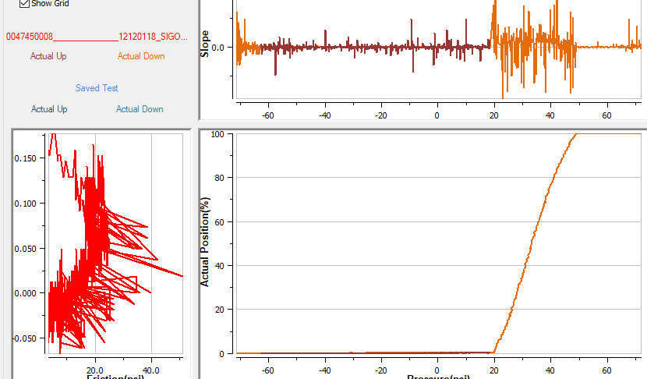

# Appendix B. Sample test results – open-loop

Shown below are graphical test results for different valves. They are a screenshot of the test run log and a screenshot of graphical test results (in reddish colors) vs. closed-loop signature (in bluish colors).

The elapsed run time always includes saving signature to the device and uploading it to the DTM.

The heading x y z means from x% to y% with a nominal speed z %/s

Of interest is 9 95 2 on Varipak. Did the test catch a few slips (highlighted) or was it a fluke?

## Springless DA 51 series

### -2 102 2

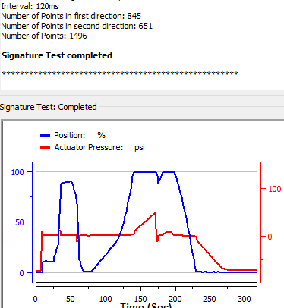

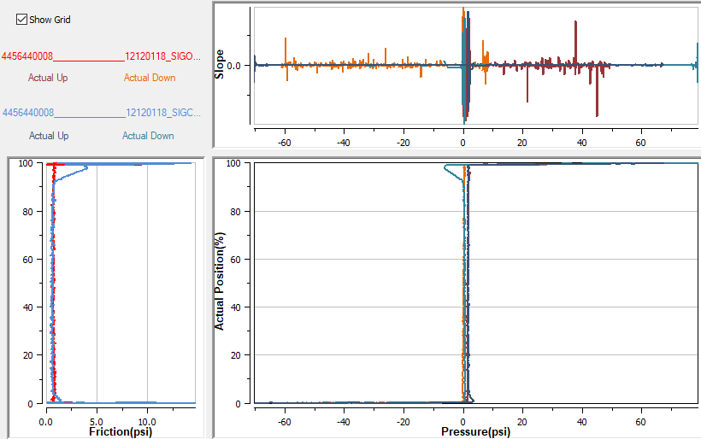

### 30 70 2

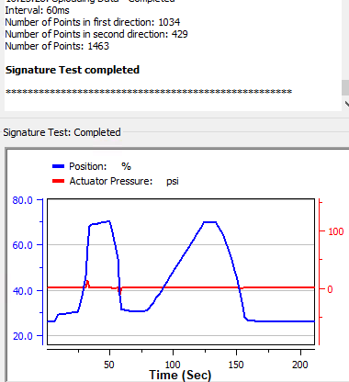

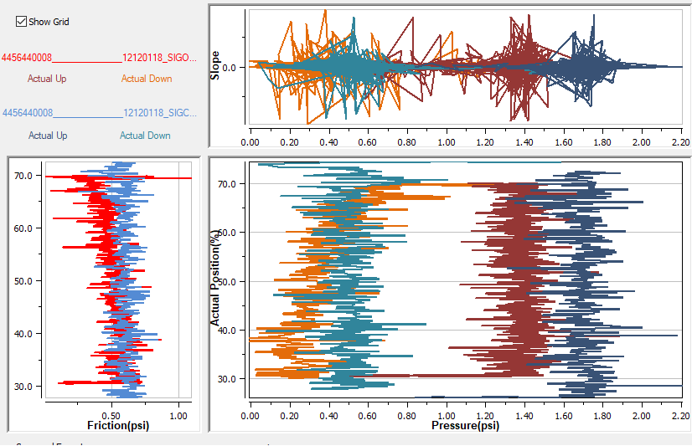

### 102 -2 2

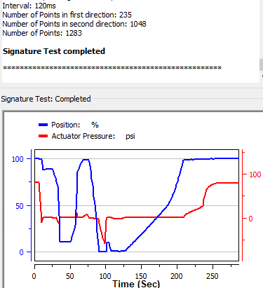

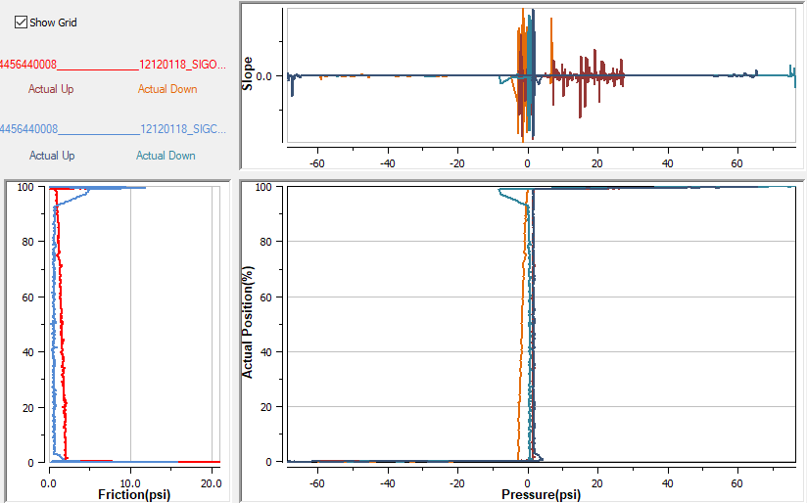

## Morin DA with a spring

### -2 102 2 – Failed to reach end position

NOTE: older firmware build (C93990)

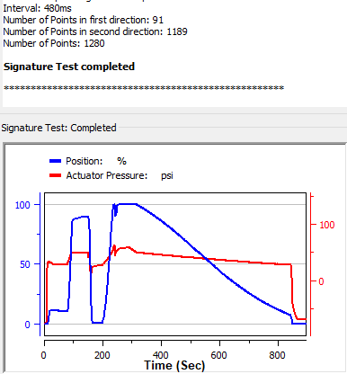

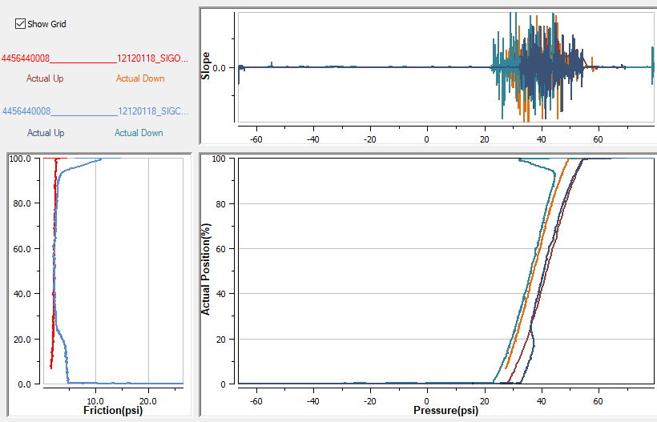

### -2 102 2

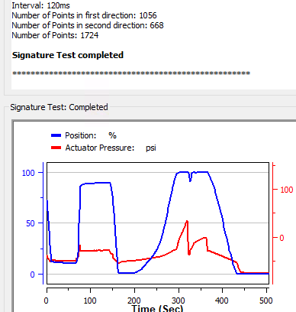

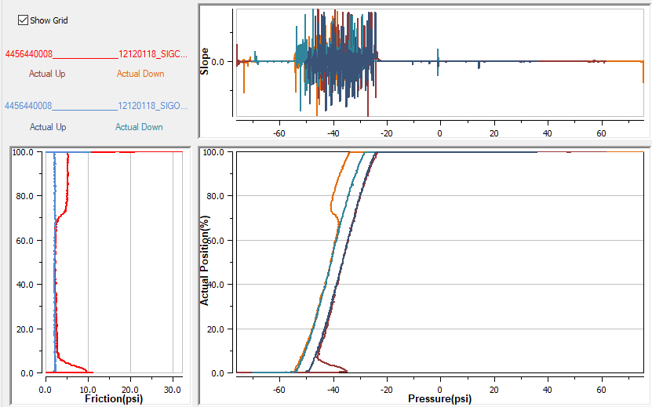

---- After correcting P1/P2 piping

### 30 70 2

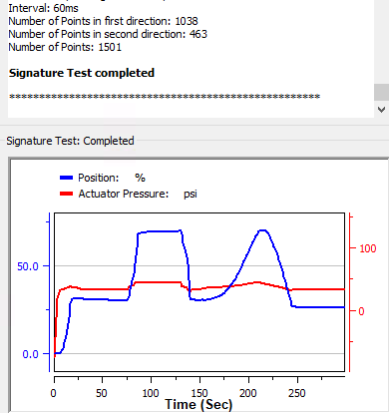

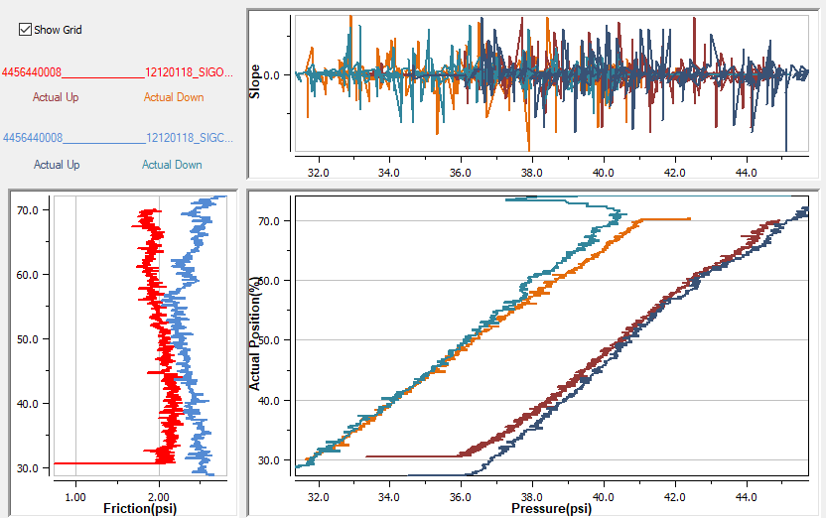

### 102 -2 2

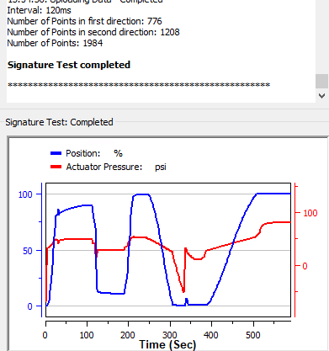

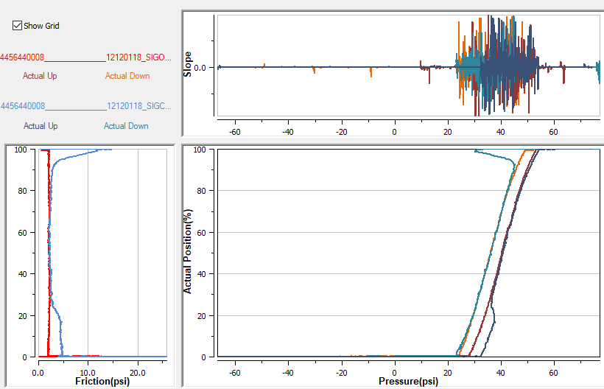

## SA ATC

### -2 102 2

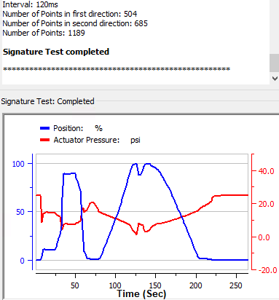

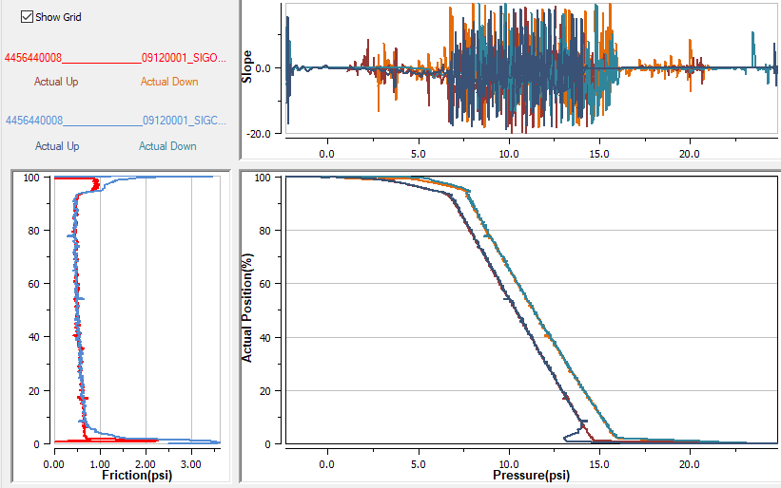

### 30 70 2 – Failed to reach start position

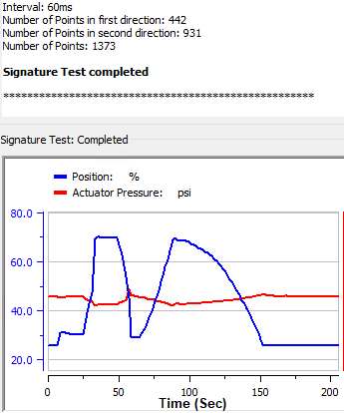

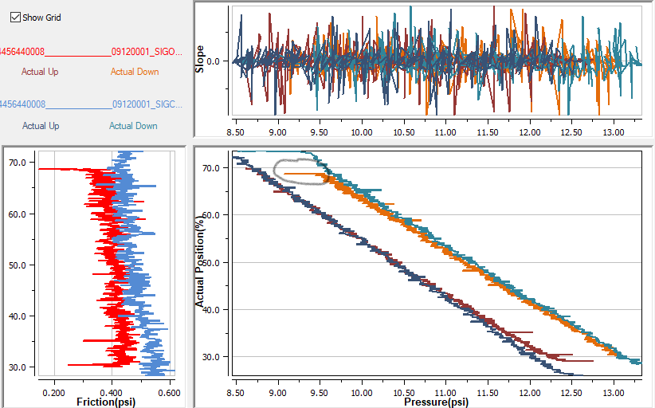

### 102 -2 2

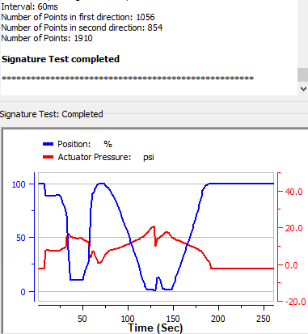

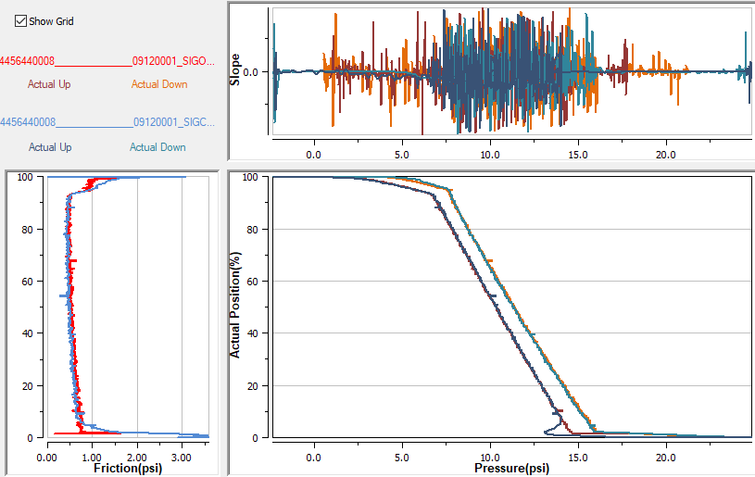

## SA ATC (Varipak)

### 9 95 2

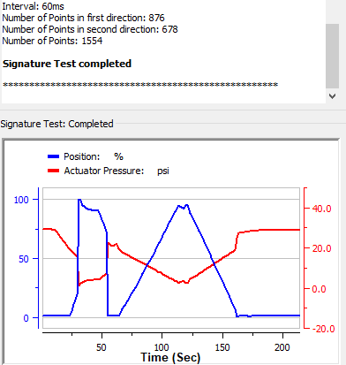

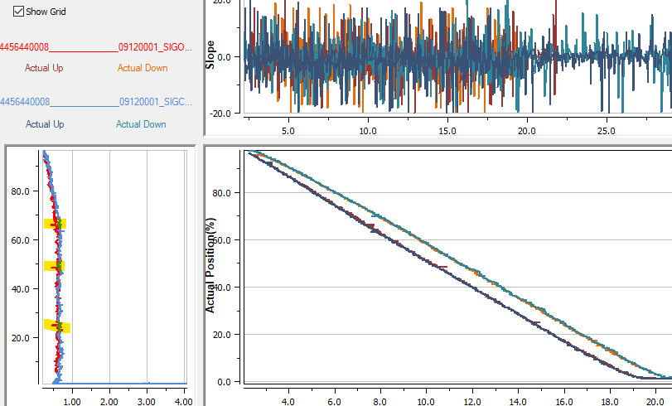

### 102 -2 2

